Business Requirements Document(BRD) Template
Project/Initiative
Month 20YY
Version X.XX

Company Information

Document Revisions
Date | Version Number | Document Changes
05/02/20xx | 0.1 | Initial Draft

Approvals
Role | Name | Title | Signature | Date

Introduction

Project Summary

Objectives
Increase the percentage of successfully confirmed hotel bookings on the TravelMate platform from 50% to 70% within 6 months after feature release by introducing new hotel search and filtration mechanisms and implementing marketing tags during a search.
Increase the percentage of overall business profit on the TravelMate platform by 30% within 6 months after feature release by introducing a hotel recommendation mechanism based on the partnership agreements and marginality.

Background
[Provide a brief history of how the project came to be proposed and initiated, including the business issues/problems identified, and expected benefit of implementing the project/developing the product.]

Business Drivers
[List the business drivers that make development of this product important. These can be financial, operational, market or environmental.]

Project Scope

In Scope Functionality
- Hotel search using multi-criteria filters
- Hotel cards with key information
- Display of hotels with partnership agreements and high marginality
- Display of marketing tags
- Autocomplete function
- Calendar view function
- Map view function
- Real-time update of hotel availability status
- Saving logs of ‘No results found’ cases
- Currency and language change

Out of Scope Functionality
- Main website’s page
- Adding new hotels
- Editing existing hotel information on the platform
- Hotel's detailed information page
- Hotel booking and payment processing
- Marginality calculation
- Communication between guest and hotel via chat

System Perspective
[Provide a complete description of the factors that could prevent successful implementation or accelerate the projects, particularly factors related to legal and regulatory compliance, existing technical or operational limitations in the environment, and budget/resource constraints.]

Assumptions

Constraints

Risks

- .

Issues

Business Process Overview
[Describe how the current process(es) work, including the interactions between systems and various business units. Include visual process flow diagrams to further illustrate the processes the new product will replace or enhance.
Use case documentation and accompanying activity or process flow diagrams can be used to create the description(s) of the proposed or “To-Be” processes.]

Current Business Process (As-Is)
At any point during or after deployment of web apps or web sites (internal or external) to support business activities, development/support teams may create and deploy widgets.
- CMS / database administrators for the employee portal use the CMS tool to create widgets. They can test widgets in the designated staging environment, then register them and deploy to production.
- Development teams may deploy widgets to development and testing environments set up for their development projects. They must check widget code into and out of the source code repository according to their projects’ development schedule.
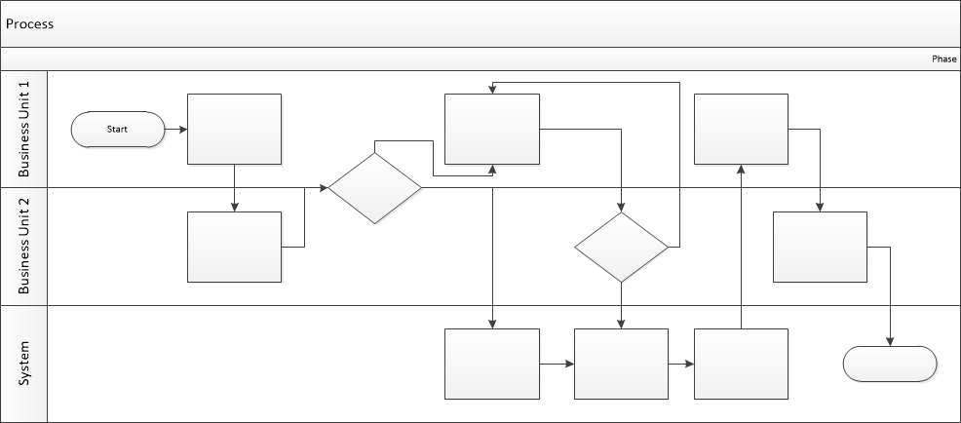

Proposed Business Process (To-Be)
- Technical Lead searches repository
- If widget is not found, user creates a new widget name record.
- WINS validates that all fields have been completed.
- WINS confirms that no similar widgets exist
- User confirms record to be created.

- User searches repository to locate existing widget description.
- WINS displays record
- User selects Edit to open and modify record
- WINS validates all fields completed correctly
- User confirms changes.
- WINS confirms changes and updates Audit table.


Stakeholder Requirements
SR-01: Travelers must be able to search for a hotel by key information (destination, dates, guests, etc.)
SR-02: Travelers must be able to apply multi-criteria filters during a hotel search
SR-03: Travelers must be able to view the main details (overall price, a photo, location etc.) on the hotel's card
SR-04: Travelers must be able to select currency and interface language
SR-05: Travelers must be able to see marketing tags
SR-06: Travelers must be able to receive destination suggestions (autocomplete) while typing a search query
SR-07: Travelers must be able to select check-in/check-out dates using an interactive calendar view
SR-08: Travelers must be able to view hotel locations on an interactive map
SR-09: Travelers must be able to see real-time (up-to-date) hotel availability status
SR-10: The business must be able to benefit from partnership agreements and marginality
SR-11: The business must be able to log "No results found" cases

The requirements in this document are prioritized as follows:
Value | Rating | Description
1 | Critical | This requirement is critical to the success of the project. The project will not be possible without this requirement.
2 | High | This requirement is high priority, but the project can be implemented at a bare minimum without this requirement.
3 | Medium | This requirement is somewhat important, as it provides some value but the project can proceed without it.
4 | Low | This is a low priority requirement, or a “nice to have” feature, if time and cost allow it.
5 | Future | This requirement is out of scope for this project, and has been included here for a possible future release.

Functional Requirements
Req# | Priority | Description | Rationale | Use Case Reference | Impacted Stakeholders
General / Base Functionality
FR-G-001 | 1 | The user can search for hotels using key details (destination, check-in and check-out dates, number of guests, age of guests) and clicking on a ‘Search’ button. | Crucial functionality for a hotel search |  | Users
FR-G-002 | 1 | After searching by key details, the user can apply key filters:  - Price per night  - High review score (8+)  - Free cancelation  - Breakfast included  - Facilities (Free Wi-Fi, parking) | Important functionality for a hotel search to find desirable hotels quicker  Price per night - to better fit users’ budget.  High review score (8+) - to find the most comfortable option  Free cancellation - to improve users’ loyalty.  Breakfast included - to better fit users’ needs  Facilities (Free Wi-Fi, parking) - to better fit users’ needs |  | Users
FR-G-003 | 1 | After searching, the system must display hotel cards with key information:  - Name of hotel (with a link to the hotel detailed information page)  - Number of stars  - Hotel’s rating  - A photo of a room  - Address  - Distance to the city center or famous landmarks  - Overall price (including all taxes and charges)  - ‘Show on the map’ functionality  - A button with a link to the hotel detailed information (implementation of hotel detailed information page is out of scope) | It is important for users to know the main details about a hotel to make the best choice. |  | Users
FR-G-005 | 1 | When a hotel displayed in the search results receives ‘Unavailable for booking’ status while the user is on the page, the system must display a ‘No available rooms’ message on the hotel card. | To avoid double booking |  | Users
FR-G-006 | 1 | When the user performs a search and after refreshing search results, the system must not display hotels with ‘Unavailable for booking’ status in the search results | To avoid double booking |  | Users
FR-G-007 | 2 | The system must display a ‘Best price’ tag on the hotel card if the price is on discount | To encourage users to make a decision quicker |  | Users, Hotel owners, Business owner
FR-G-008 | 2 | The system must display a ‘{number} rooms are left’ on the hotel card if the =< 5 rooms are available. | To encourage users to make a decision quicker |  | Users, Hotel owners, Business owner
FR-G-009 | 2 | The system must display a ‘No hotels found’ message on the search results page if no corresponding hotels are found during the search. | So that users know what is the problem |  | Users
FR-G-010 | 2 | The system must display search results in the following order: hotels with partnership agreements, hotels with high marginality, other hotels. | So that business has higher chances to benefit from partnership agreements and marginality |  | Users, Hotel owners, Business owner
FR-G-011 | 3 | The system must visually highlight hotels which have a partnership agreement, high marginality, or both in the search results. |  |  | Users, Hotel owners, Business owner
Security Requirements
FR-S-001 | 1
Reporting Requirements
FR-R-001 | 3 | When FR-G-009 triggers, the system saves logs of the selected filters during the search. | To expand the hotel portfolio in underserved segments. |  | Users, Business owner
Usability Requirements
FR-U-001 | 3 | The system must apply an auto-complete function when the user enters ‘Destination’. | For better UX |  | Users
FR-U-002 | 3 | When the user chooses 'check-in' and 'check-out' dates, the system must display dates in a calendar format. | For better UX |  | Users
FR-U-003 | 2 | The system must display prices in the currency that corresponds to the user's geographic location by default. | For better UX |  | Users
FR-U-004 | 1 | The user can choose currency in which hotel prices are displayed | For better UX |  | Users
FR-U-005 | 1 | The system must convert and display hotel prices in the currency selected by the user. | For better UX |  | Users
FR-U-006 | 1 | The system must display the interface in language that corresponds to the user's geographic location by default. | For better UX |  | Users
FR-U-007 | 1 | The user can select an interface language from a list (e.g., English, Ukrainian, German) | For better UX |  | Users
FR-U-008 | 1 | After language selection, the system must display all interface elements in the selected language. | For better UX |  | Users
Audit Requirements
FR-A-001 | 1

Non-Functional Requirements
[Include technical and operational requirements that are not specific to a function. This typically includes requirements such as processing time, concurrent users, availability, etc.]
ID | Requirement
NFR-001 | The system must carry out FR-G-005 in less than 1 second.
NFR-002 | The system must carry out FR-G-006 in less than 1 second.
NFR-003 | The system must display the search results in less than 2 seconds.
NFR-004 | Currency conversion must be applied and displayed within 1 second after the user's selection.
NFR-005 | The system supports the following currencies: USD, EUR, GBP. UAH
NFR-006 | The system supports the following interface languages: English, Ukrainian, French, German, Spanish.
NFR-007 | The system must support operating in such browsers as Chrome, Firefox, Safari, and Edge.
NFR-008 | The system must support operating in such devices as smartphone, tablet, computer screen.
NFR-009 | The system must support operating in such operating systems as Windows, macOS, Linux, Android, and iOS.
NFR-010 | The system must work correctly in the last two versions of major browsers.

Appendices

List of Acronyms
[If needed, create a list of acronyms used throughout the BRD document to aid in comprehension.]

Glossary of Terms
[If needed, identify and define any terms that may be unfamiliar to readers, including terms that are unique to the organization, the technology to be employed, or the standards in use.]

Related Documents
[Provide a list of documents or web pages, including links, which are referenced in the BRD.]

